**Faculty of Computers and Artificial intelligence**

Course Name: Selected topics in computer science -2

Team Number: 19

|  |  |
| --- | --- |
| Name | ID |
| اندرو ابراهيم اسحق | 202000167 |
| بولا نبيل فايز | 202000210 |
| عبدالرحمن مصطفى عبدالعزيز موسي | 202000538 |
| فيلوباتير منصور جريس منصور | 202000651 |
| كيرلس هانى اسحق عبدة | 202000683 |
| مارك رأفت سركيس | 202000690 |
| محمد على ربيع عبد الجواد | 202000801 |

***Paper details:***

1. **Authors name: Biagio La Rosa, Roberto Capobianco & Daniele Nardi**

**paper name: A self-interpretable module for deep image classification on small data**

**year of publication: 05 August 2022**

**Dataset: SVHN**

**https://www.kaggle.com/datasets/stanfordu/street-view-house-numbers**

1. **The implemented algorithms: KNN**

**Result: These results confirm our hypothesis that the additional information captured by the input encoding allows the model to exploit other shortcuts and to reach the best performance. Moreover, even though it uses only the memory set to compute the prediction, its interpretability is comparable to Memory Wrap.**

**Memory Wrap has the potential to enhance these methods by exploiting the fact that it naturally selects suitable counterfactual classes and images, providing additional information.**

***Project Description Document:***

1. General Information on the selected dataset:

|  |  |
| --- | --- |
| Name of the dataset used | Street View House Numbers (.h5 File) |
| Link of dataset | https://www.kaggle.com/datasets/sasha18/street-view-house-nos-h5-file |
| The total number of samples in the dataset | 60000 |
| The dimension of images | 32x32 |
| Number of classes and their labels | 10 classes [0,1,2,3,4,5,6,7,8,9] |

b. Implementation details:

|  |  |  |
| --- | --- | --- |
|  | Ratio | Number of images |
| Training | 0.70 (70%) | 42000 |
| Validation | 0.15 (15%) | 9000 |
| Testing | 0.15 (15%) | 9000 |

* A block diagram for the implemented model showing the main steps and specify in each block the used algorithm(s).

* Hyperparameters used in your model:

activation=relu, softmax

**optimizer=adam**

**loss=sparse categorical crossentropy**

**metrics=accuracy**

**batch size=64**

**epochs=50**

c. Results details:

* The measures that are used in evaluation:

accuracy: 0.97

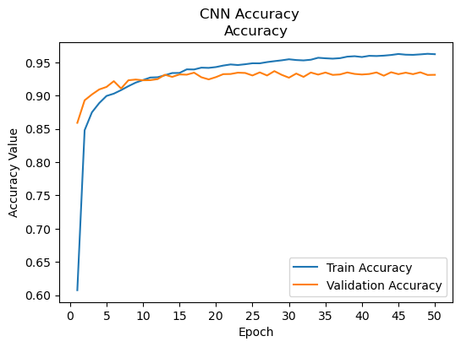

loss: 0.1127

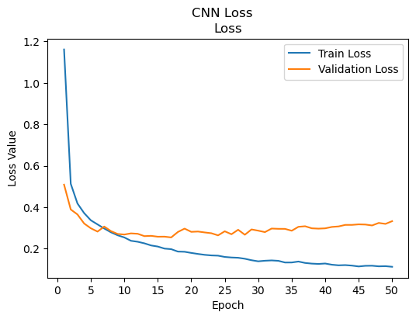

precision: 0.93

recall: 0.93

f1-score: 0.93

* Result sample:

